Name:

PRN No:

Batch:

**High Performance Computing Lab**

**Practical No. 8**

**Problem Statement 1:** Study and implement 2D Convolution using MPI. Use a different number of processes and analyze the performance.

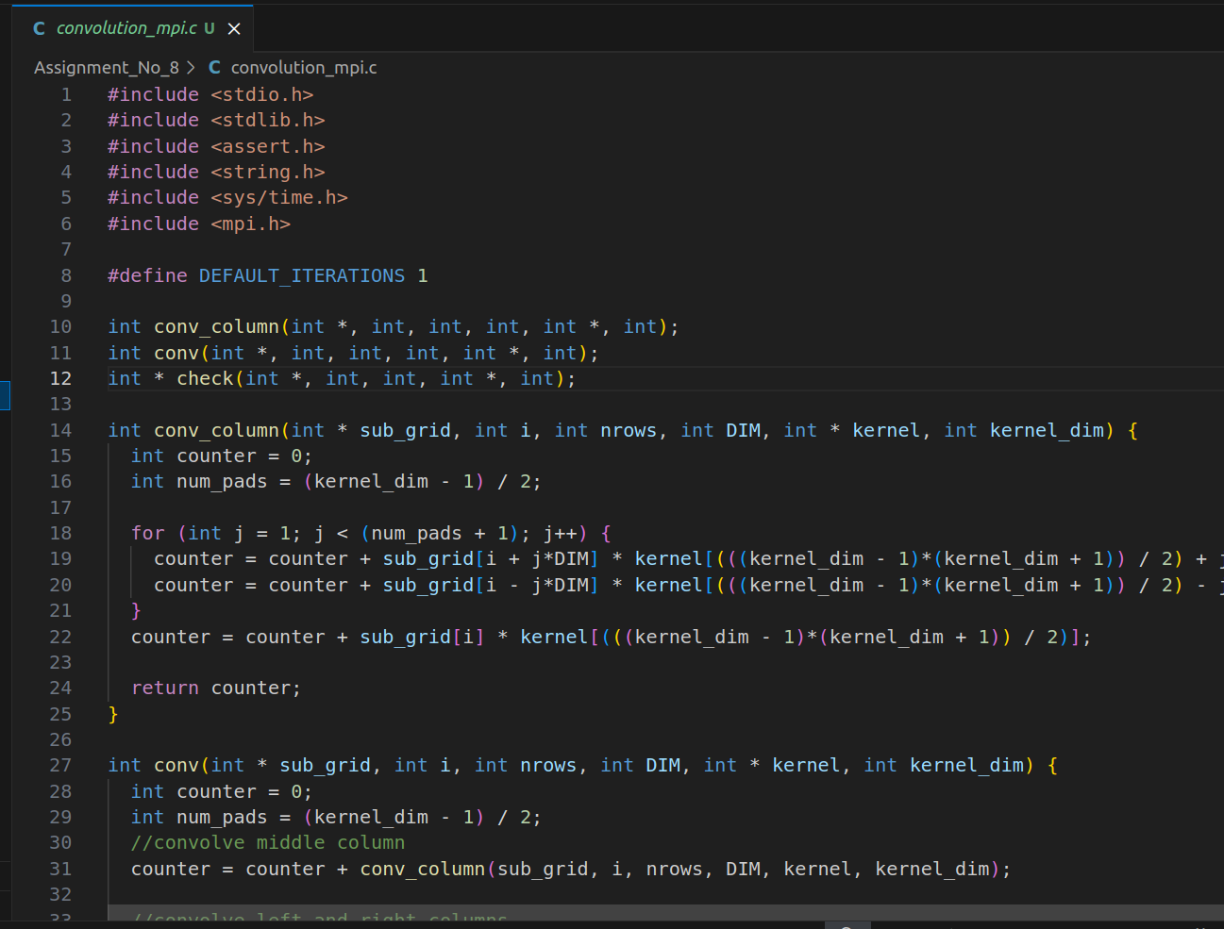

**Problem Statement 2:** Implement dot product using MPI. Use different number of processes and analyze the performance.

